ABOUT MY CLASSROOM:  Start of Class:  - Be in your seat, quietly ready to start when the bell rings.  - Complete the warm-up activity.  - Every three tardies = write-up.  Materials:  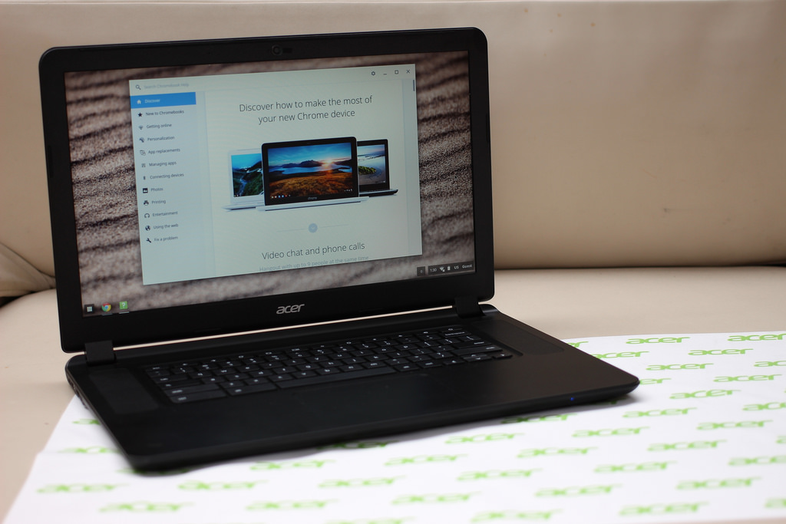  - Pen or pencil (I do not provide.)  - Chromebook (CHARGED)  - Silent Reading Book  - Folder/binder  - Pearson workbook  Supplies:  - You may borrow any supplies on the back counter.  - Take care of them.  - Return them the way you found them.  Lavatory/Nurse:  - Please ask at appropriate times- independent work, last 10 minutes. NOT AT BEGINNING OF CLASS!  - Have a pass ready to sign.  - Sign out and back in completely.  - NO DRINKS- get one before class starts.  End of Class:  - I dismiss you, not the bell.  - Do NOT line up at the door.  - Make sure your area is clean. | 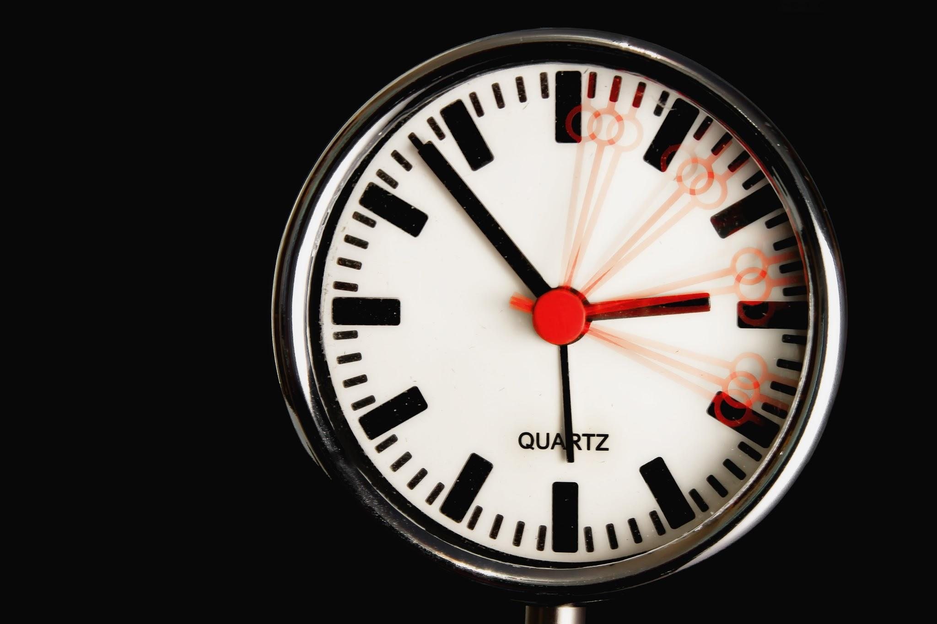  Class Rules:  - Be on time.  - Be prepared.  - Be respectful.  - Follow directions.  Chromebooks:  - Bring every day.  - Make sure they are charged.  - Keep lid closed unless told otherwise.  - No games or gmail unless given permission.  Phones:  - I should NOT see or hear them.  - It will be taken to the office for you to deal with at the end of the day.  Food/Drink:  - Ask permission before eating or drinking anything in class.  - If I give you something, make sure you throw away your trash.  Trash:  - Throw away trash at appropriate times, not while I am teaching.  - Do not leave trash in your desk or on the floor.  - Please be nice and pick up trash, even if it is not yours. | Desks:  - Do not write in or on YOUR desk.  - Do not put gum in or under YOUR desk.  - Do not touch/take anything from MY desks/work areas without permission.  - Do NOT go behind my podium without permission.  Classroom LIbrary:  - Ask permission to sign out a book. You may have one out at a time.  - You will be asked to replace the book if you lose or damage it. Treat books kindly.  - See me if you need recommendations.  Plagiarism  - Do not copy from friends, the Internet, or any other source.  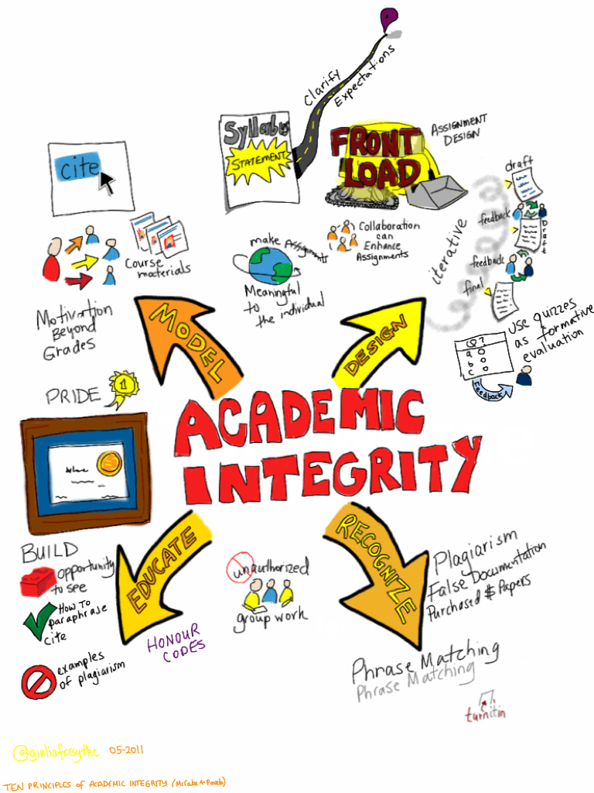  - You will receive a zero, and your parent will be contacted.  Extra Credit:  - It is available.  - Word of the Day  - Book Project  - Miscellaneous Activities (up to 20 points max per quarter)  - Owed work must be completed first.  Teacher Page:  - Located on the district website  - Contains information to help you be successful (WOTD, Projects, etc.)
Grading:  - Homework 10%  - WOTD Quizzes/Classwork 40%  - Class Participation/Preparation 5%  - Projects/Major Writing AssignmentsTests 45%  Homework:  - Posted daily on back board and grade level homework site  - Write it in your planner!  - No homework? Read or study (notes/WOTD).  Late Work:  - Homework may be turned in the next day only for HALF credit.  - Projects lose 5 points for each day they are late.  Tests/Quizzes:  - Announced in advance  - Use resources provided  - Talking/cheating earns you a zero and a parent contact  - Test corrections available on major tests only (if you score below 70%)  Absences:  - Check with a friend and check Google Classroom for missed WOTD, notes, and/or assignments.  - Check homework board.  - See me for any necessary handouts.  - You have one day to make up work for each day you miss. |  | 8th Grade  Communications  Mrs. Pacharis  pacharisj@muhlsdk12.net      Name__________________________  Period _________________________  Parent Signature*_____________________________  *Signifies that your child has shared this syllabus with you

