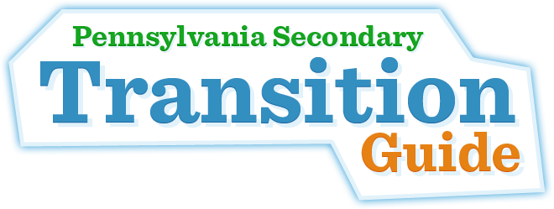

Parents and Guardians, the website [**www.secondarytransition.org**](http://www.secondarytransition.org) is sponsored by the [Pennsylvania Department of Education](http://www.education.state.pa.us/), [Bureau of Special Education](http://www.education.state.pa.us/portal/server.pt/community/bureau_of_special_education/7340) on behalf of the [Pennsylvania Community on Transition](http://secondarytransition.org/page/pennsylvania_community_of_practice_on_secondary_transition_pact). The [Pennsylvania Community on Transition](http://secondarytransition.org/page/pennsylvania_community_of_practice_on_secondary_transition_pact) is a group of various stakeholders from across Pennsylvania who work collaboratively to ensure appropriate transition outcomes for Pennsylvania youth and young adults.

This website, which is continually updated, provides youth, young adults, parents, and professionals with secondary transition resources to facilitate a young person’s progress towards post-secondary goals related to education, employment, and community living. Scroll through this homepage to find topics that are of interest to you.

The website provides links and resources on the following topics:

* Agencies & Supports
* Financial Supports & Services
* Health
* Employment
* Self-Determination
* Post-Secondary Education & Training
* Recreation & Leisure
* School
* Community Living

[**www.secondarytransition.org**](http://www.secondarytransition.org)