Name: ________________________________________________ Period: ______
Mid Term Study Guide
Directions: Complete the following questions on the study guide to the best of your ability. Then use this study guide to study for the upcoming unit test. Also study your notes, textbook, and any vocab and worksheets you did in class.
- The land bridge that once connected Siberia and Alaska is now what body of water? (page 6)

- What is monotheism? (page 22)

- What is the Columbian Exchange? (page 40)

- What was England’s first PERMANENT settlement in North America? (page 67)

- Why do we celebrate Thanksgiving? (page 70)

- List the English colonies that make up each of the following:
  - New England Colonies (71) -
  - Middle Colonies (77) -
  - Southern Colonies (84) –

- Pennsylvania and Massachusetts were founded by two distinct religious groups. What were those groups and how did they differ? (pages 72+78)

- Which colony was originally a Dutch settlement and what was its name before being taken over by the English? (page 78)

- What was the Mayflower Compact and why was it created? (page 69)

- What middle colony was known for its religious toleration and welcomed Amish and Jewish settlers? (page 78) What is religious toleration? (page 73)

- Why was John Peter Zenger taken to court? How did this set up our freedom of the press today? (page 105)

- What are Navigation Acts? Why did the colonists not like them? How did some colonists try to get around the Navigation Acts? (page 106)

- Describe how the Great Awakening influenced the colonies. (page 121)

- Who is Olauduh Equiano and what did he do? What is the Middle Passage?(page 114)

- What were some of the causes of the French and Indian War? Who won the war? (140)

- Define each of the following:
  - Stamp Act (147) -
  - Tea Act (150) -
  - Proclamation of 1763 (145) –

- What does the “shot heard round the world” refer to? Who fired this shot? (152)

- African Americans fought on both sides of the Revolutionary War. Give one reason as to why some may have fought for the British.(186)

- Briefly describe the importance of each of the following people during the American Revolution.
  - Thomas Paine (170) - -+
  - Baron von Steuben (183) -
  - Benedict Arnold (192) –

- Briefly describe the importance of each of the following events during the American Revolution.
  - Boston Massacre (page 148) -
  - Boston Tea Party (page 151)-
  - Lexington and Concord (page 152) -
  - Bunker Hill (page 159) -
  - Trenton (page 181) -
  - Saratoga (page 181) -
  - Yorktown (page 192) –

- The Declaration of Independence is one of our nation’s most sacred documents. Who wrote it? (172)

- What were the differences between patriots and loyalists?

- What were the conditions like at Valley Forge? Who taught Washington’s soldiers how to march? How did American citizens help the soldiers there? (page 184)

- What was the name of the treaty that ended the Revolutionary War? (page 193)

- What was the historical significance of Daniel Shay’s Rebellion? (page 209)

- Why did many people consider the Articles of Confederation to be too weak? (page 208)

- Compare and contrast the New Jersey and Virginia Plans?(page 213-214) What was the 3/5th Compromise? What was the Great Compromise? (page 214)

- In his farewell address what two things did Washington warn the new nation against? (page 297)

- What was Alexander Hamilton’s plan to decrease the Federal Debt? Why did Southerners initially oppose this plan? Why did they finally agree to this plan? (page 285)

Quote Analysis
Directions: Read the following three quotes and then underneath each put them into your own words.

“We must consider that we shall be as a City upon a Hill. The eyes of all people are upon us.”
– Puritan Leader John Winthrop, from “A Model of Christian Charity” 1630 (page 72)
____________________________________________________________________________________
__________________________________________________________________________________________
__________________________________________________________________________________________

“The closeness of the place, and the heat of the climate, added to the number in the ship, which was so crowded that each had scarcely room to turn himself, almost suffocated us….The shrieks of the woman, and the groans of the dying, rendered the whole a scene of horror almost inconceivable.”
– The Interesting Narrative of the Life of Olaudah Equiano (page 114)
____________________________________________________________________________________
__________________________________________________________________________________________
__________________________________________________________________________________________
__________________________________________________________________________________________

“I do, by the authority to me given by His Majesty, determine to execute martial law . . . . I do require every person . . . to resort to His Majesty’s standard, or be looked upon as traitors to His Majesty’s government, . . . subject to the penalty. . .”
– Proclamation of Virginia governor Lord Dunmore, November 1775 (page 157)
___________________________________________________________________________________
__________________________________________________________________________________________
_________________________________________________________________________________________
__________________________________________________________________________________________
Critical Thinking Questions
Directions: Use the following graphics to answer the accompanying questions.

Alexander Hamilton
• wanted the U.S. government to pay all federal and state debts.
• proposed a national bank.
• supported a high tax on imports.
• argued for a “loose” interpretation of the Constitution.
• expressed ideas opposed by southerners like paying off state debts from the Revolution
• in exchange for Southern support a new capital was to be created in the South
- Why did many Southerners oppose Hamilton’s financial plan?

- Why did southern members of Congress agree to support Hamilton’s plan?

- What type of interpretation of the Constitution did Hamilton favor?

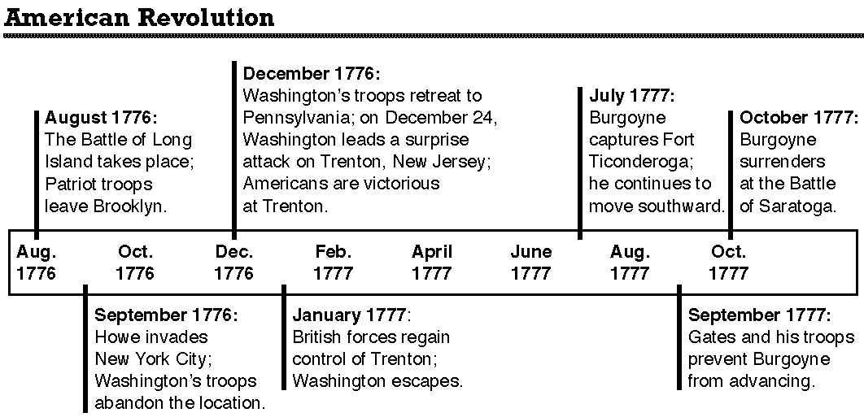
- What year does Washington’s surprise attack on Hessian soldiers at Trenton occur?

- What British general surrenders at the Battle of Saratoga?

- In December of 1776 where did Washington’s troops retreat to?

Open Ended Question(s)
Below copy down the open ended question which you will answer on the exam. Then answer the question to the best of your ability by either writing out your answers or using some form of outlining.

